Comic project

Content

1. Introduction 1

1.1. Purpose 1

1.2. Overview 1

2. Architectural Representation 2

3. Architectural Goals and Constraints 2

3.1. Goals 2

3.2 Technical Platform 2

4. Use case View 4

5. Design View 5

6. Process View 6

7. Component View 6

8. Deployement View 6

9. Data View 6

# Introduction

## Purpose

This document provides a comprehensive architectural overview of the system, using a number of different architecture views to depict different aspects of the system. It is intended to capture and convey the significant architecture decisions, which have been made on the system.

## Overview

The rest of the document includes:

Architectural representation: this section describes the current architecture of the Inspecting system.

Architectural Goals and Constraints: this section describes goals of the architecture and constraints.

Use Case View: this section lists realizations of main use cases in Comic project.

Design View: this section describes structure of main packages in Comic project.

Process View: this section describes processes and threads in Comic project.

Component View: this section describes deployment architecture of Comic project.

Deployment View: this section describes how the different systems’ hardware nodes will come to life together as well as how each of the hardware nodes will be installed and deployed

Data View: this section describes database design and scripts for generating database structure.

# Architectural Representation

Design View

Process View

Component View

Deployment View

Figure : Architecture Representation

SAD of Comic project version 1.0 is presented under multiple views and their meanings are described as below:

|  |  |  |
| --- | --- | --- |
| **No.** | **View** | **Description** |
| 1 | *Use case view* | Define main drivers of the system, which are the system requirements. |
| 2 | *Design View* | Contains any system definitions as well as class and object diagrams which depict the services that the system will provide to its end-users. |
| 3 | *Process View* | Display the processes that form the systems’ mechanism. These will be represented as collaboration, sequence, and activity diagrams. |
| 4 | *Component View* | Include system and user interface specifications, meaning, the different components that make up the system |
| 5 | *Deployment View* | Depict how the different systems’ hardware nodes will come to life together as well as how each of the hardware nodes will be installed and deployed |

Table : Architectural Representation Description

# Architectural Goals and Constraints

## Goals

**The Comic project architecture has been designed with the following objectives in mind:**

The primary purpose is to build a repository of comic and interactive with user. User can read, comment, edit,etc.. and that is the rationale creating the site

## Technical Platform

HTML, CSS, Java Script, Angular JS, Material Angular JS

Web Framework

**ASP.NET MVC 5**

Object Relational Mapping (ORM)

**.NET Entity Framework 6**

Figure : Technical Platform

# Use case View

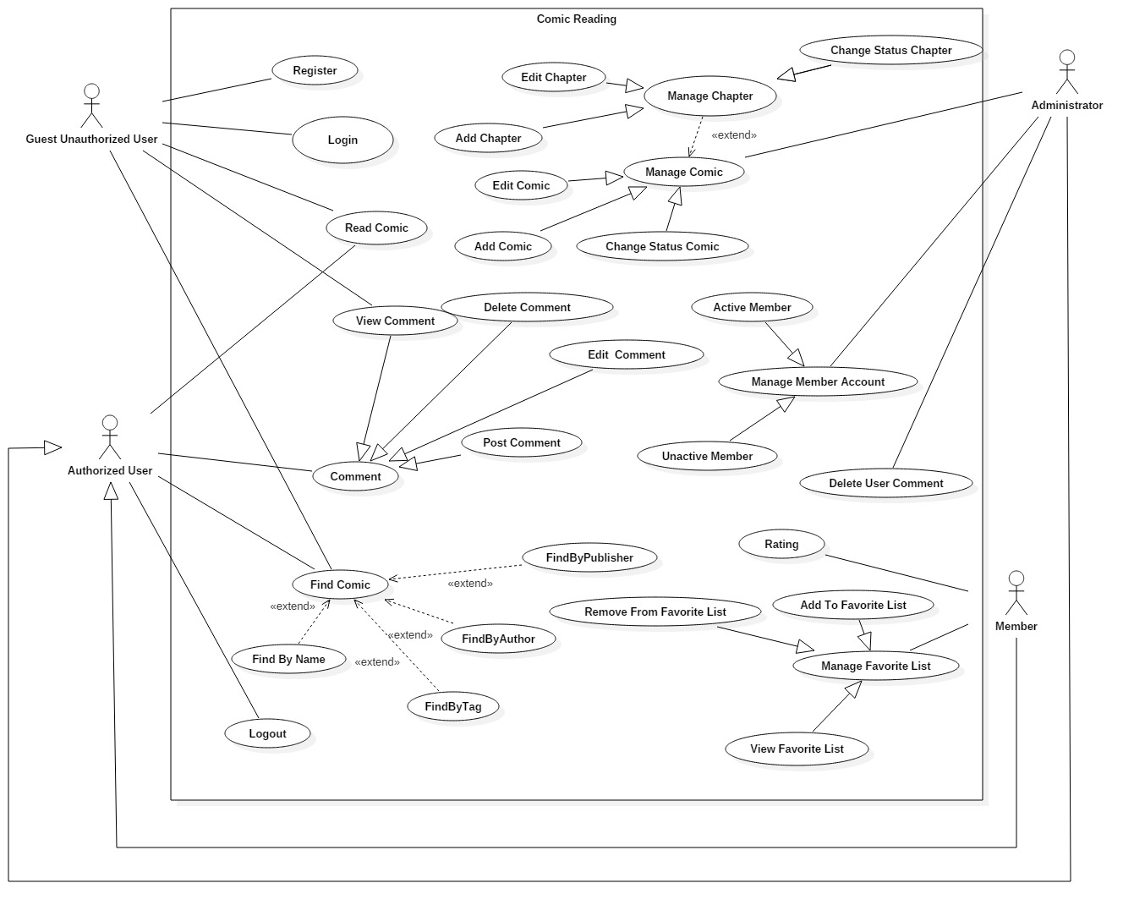

Figure : Use case View

# Design View

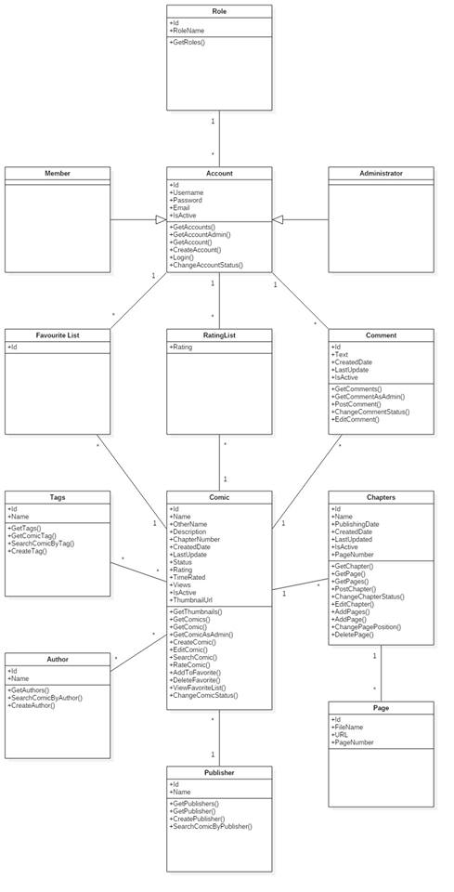

Figure : Class diagram

# Process View

**ACTIVITY DIAGRAM**

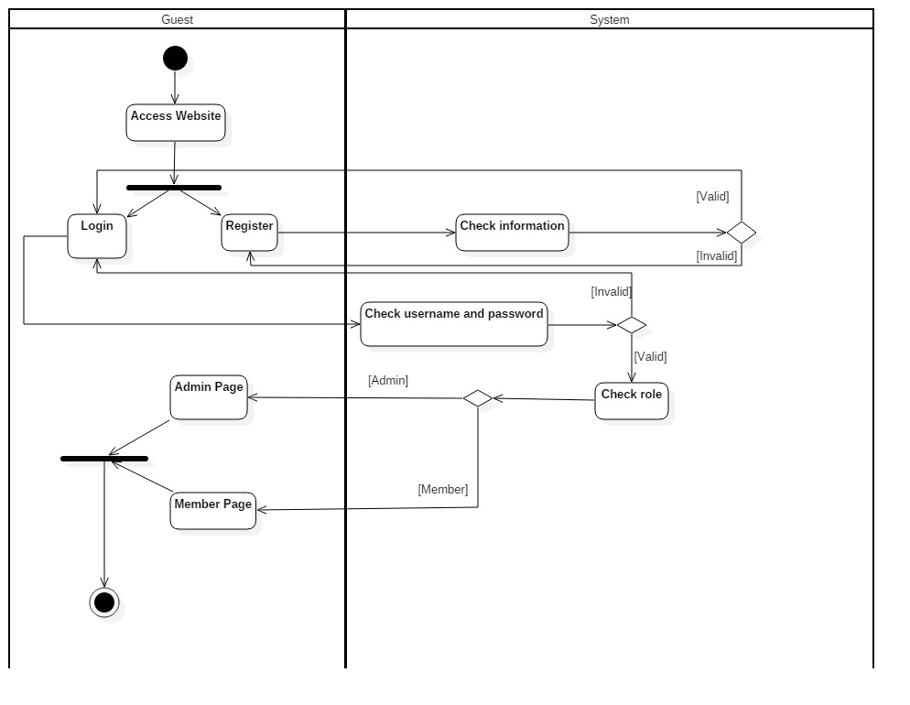

Figure 6 - Login Activity Diagram

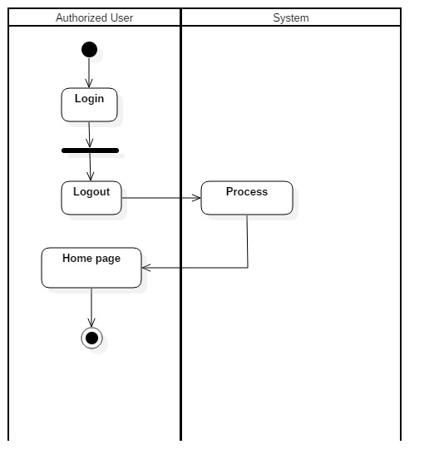

Figure - Logout Activity Diagram

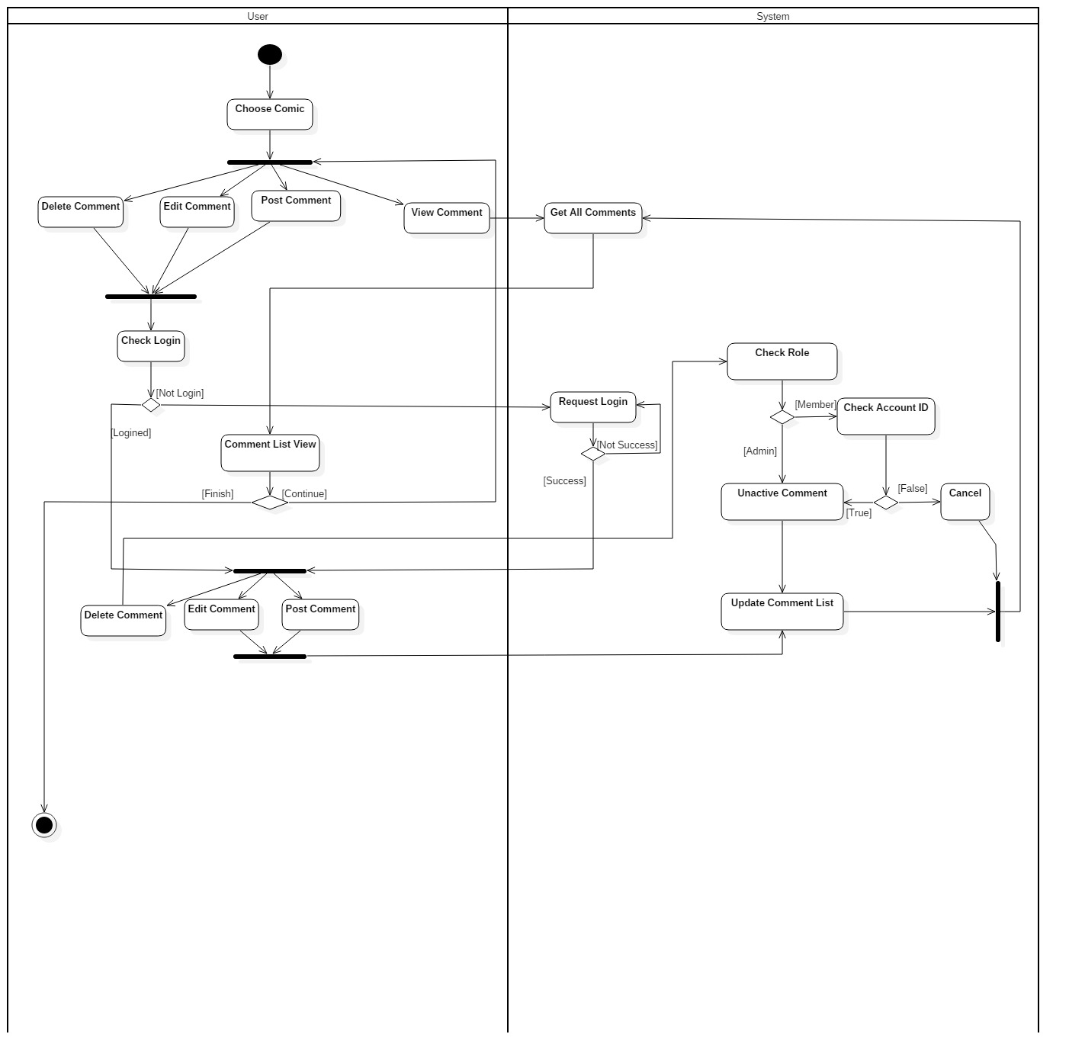

Figure - Comment Activity Diagram

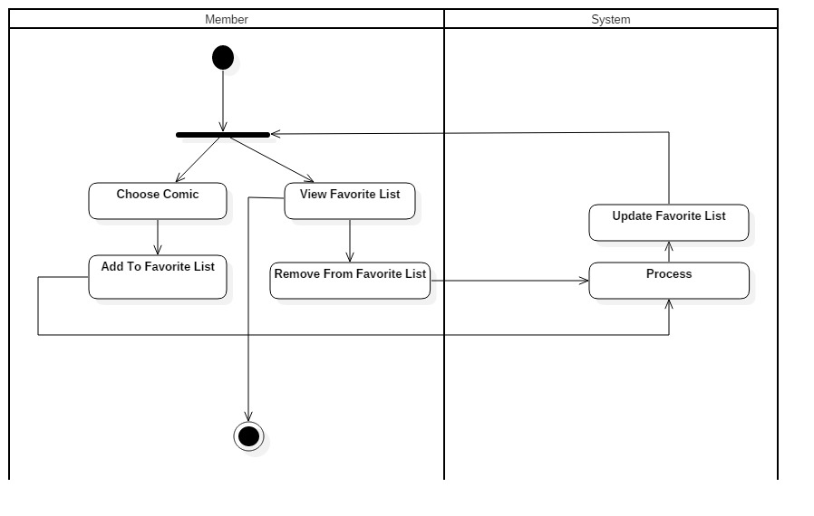

Figure - FavoriteList Activity Diagram

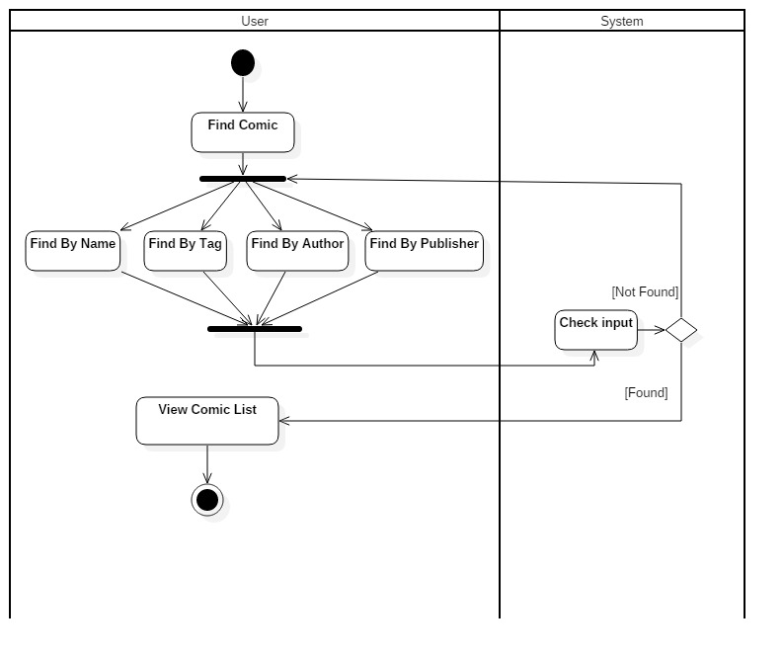

Figure – Find Comic Activity Diagram

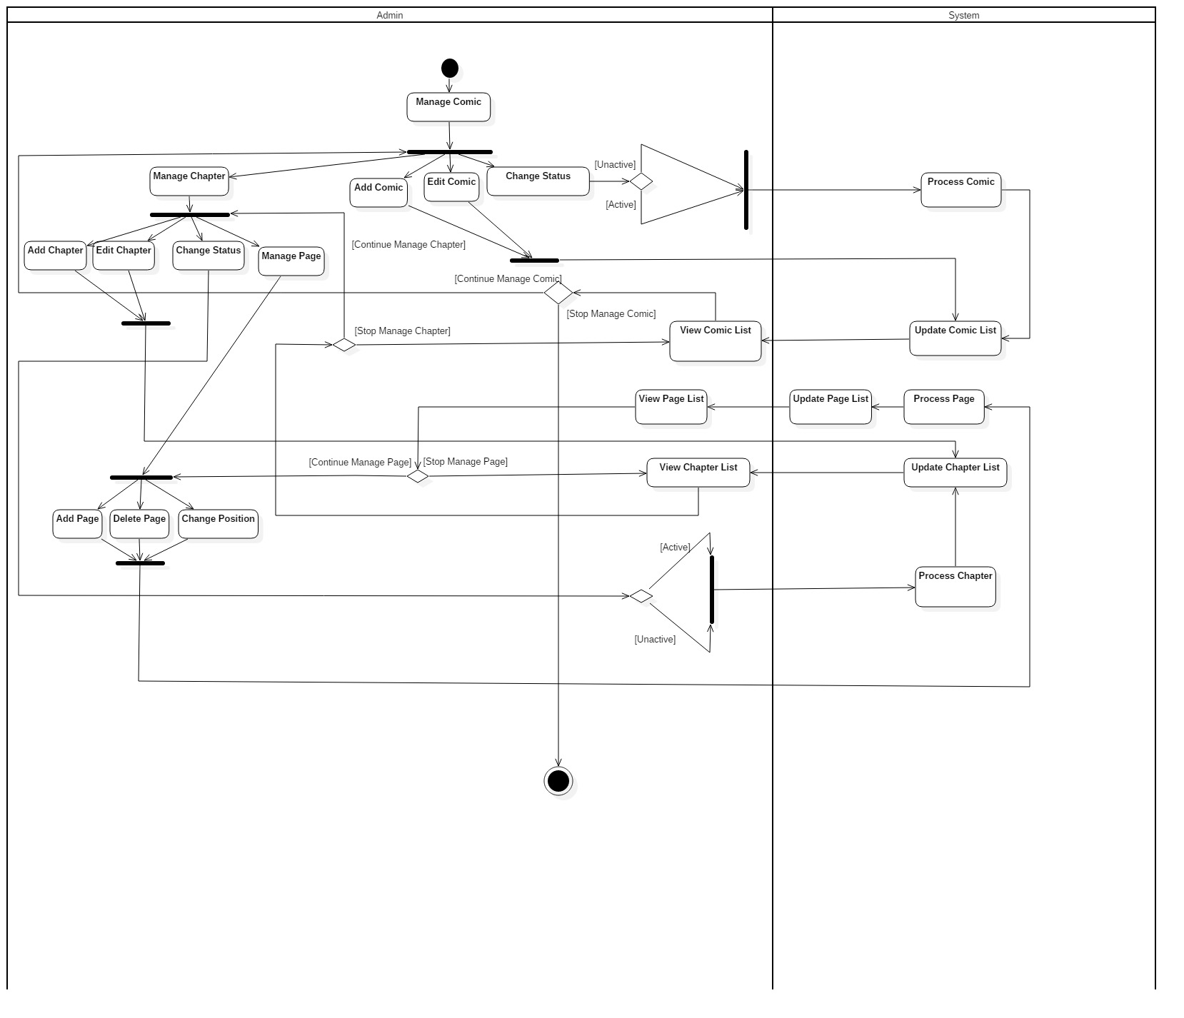

Figure – Manage Comic Activity Diagram

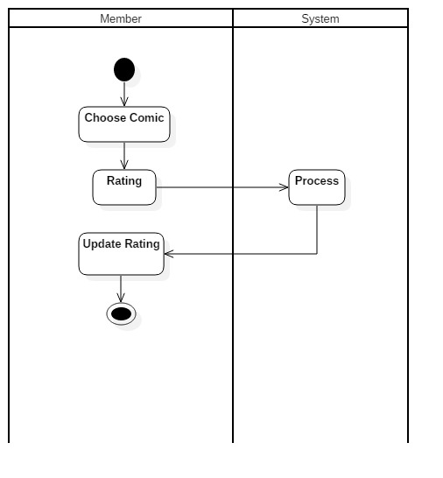

Figure - Rating Activity Diagram

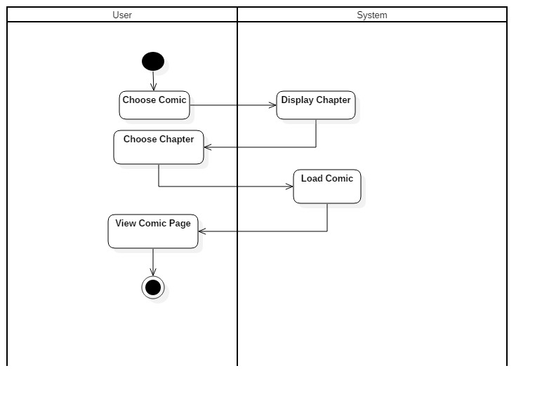

Figure – Read Comic Activity Diagram

**SEQUENCE DIAGRAM**

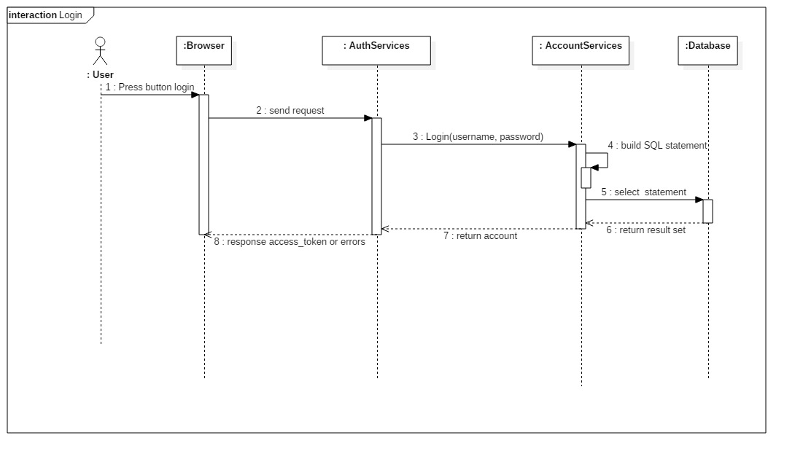

Figure 22: Login sequence diagram

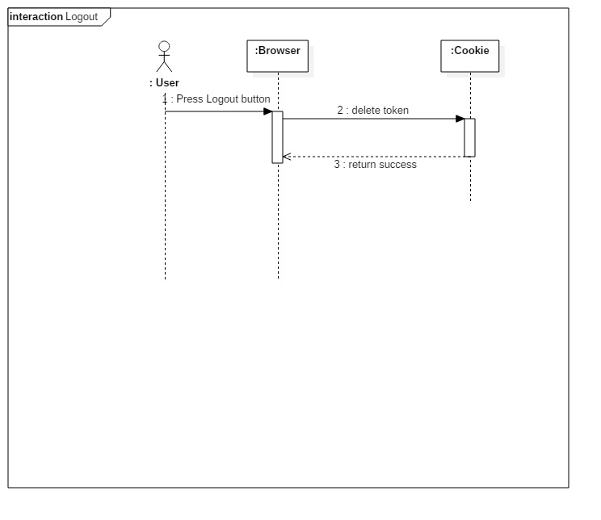

Figure 23: Logout sequence diagram

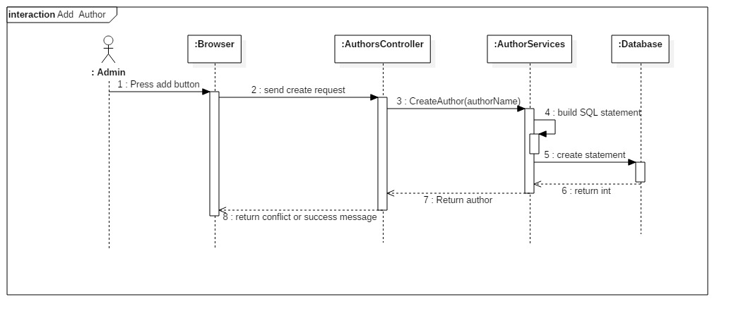

Figure 24: Add Author

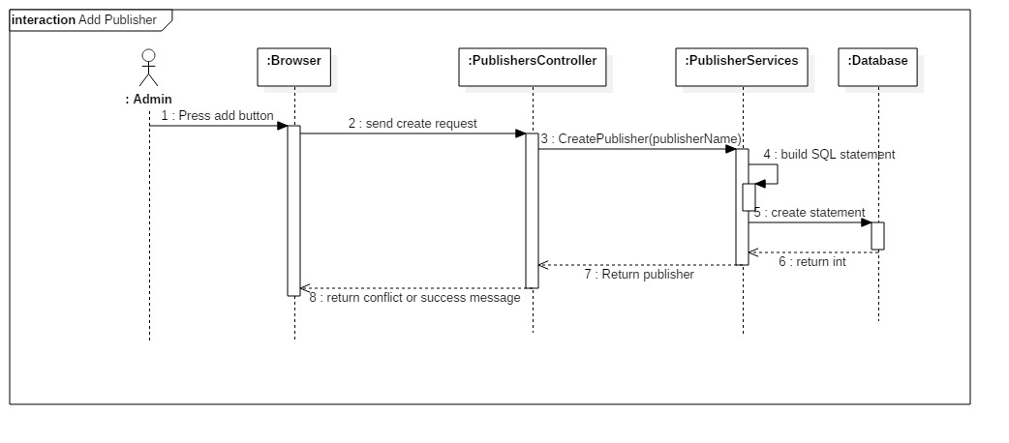

Figure 25: Add publisher

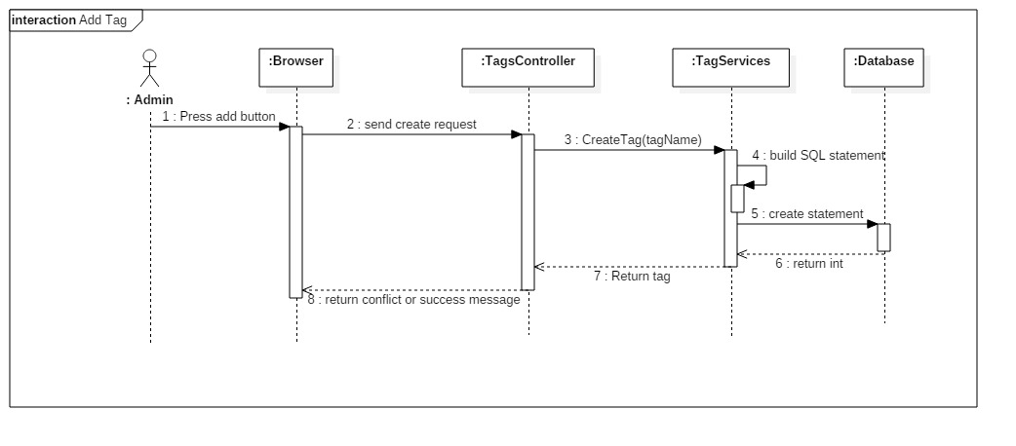

Figure 26: Add Tag

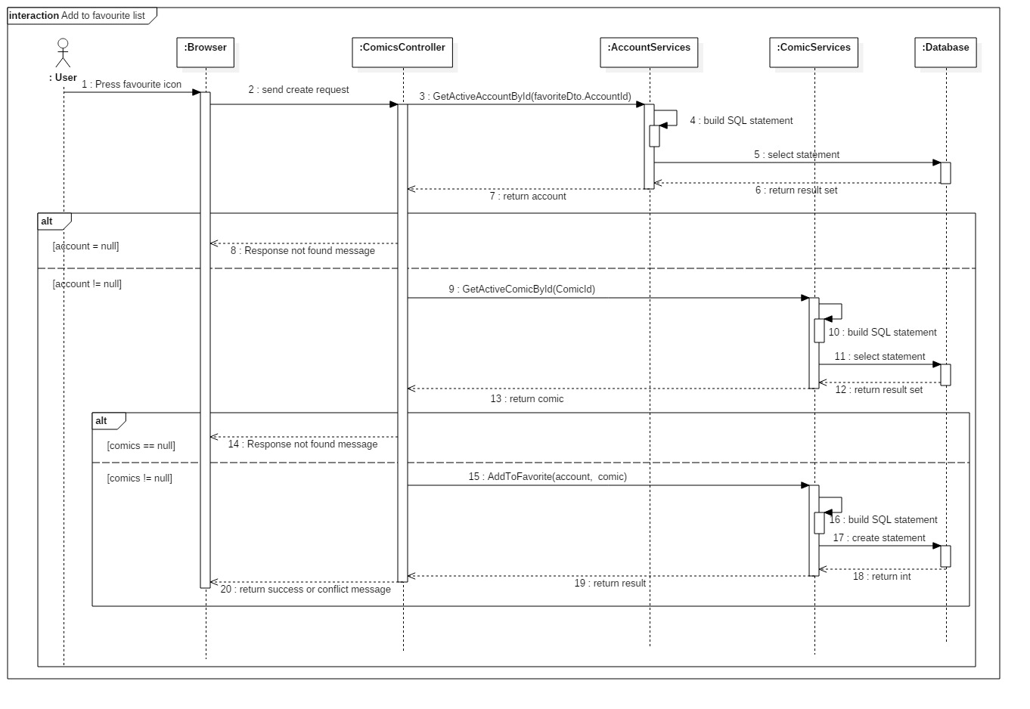

Figure 27: Add to favourite list

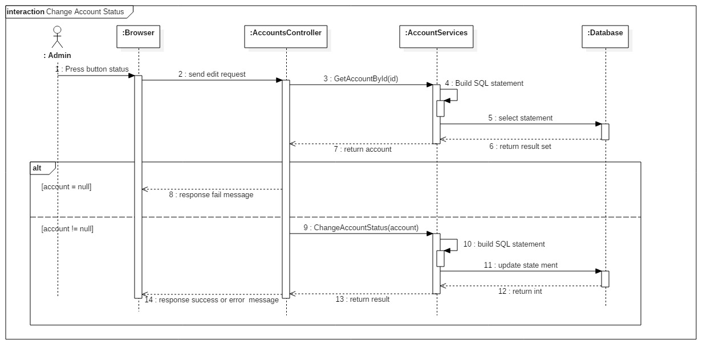

Figure 28: Change account status

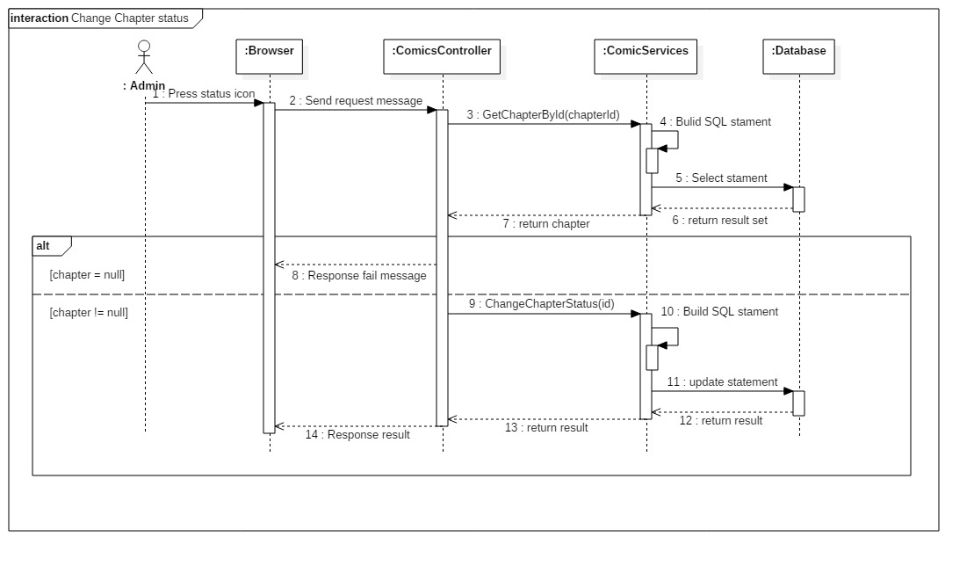

Figure 29: Change chapter status

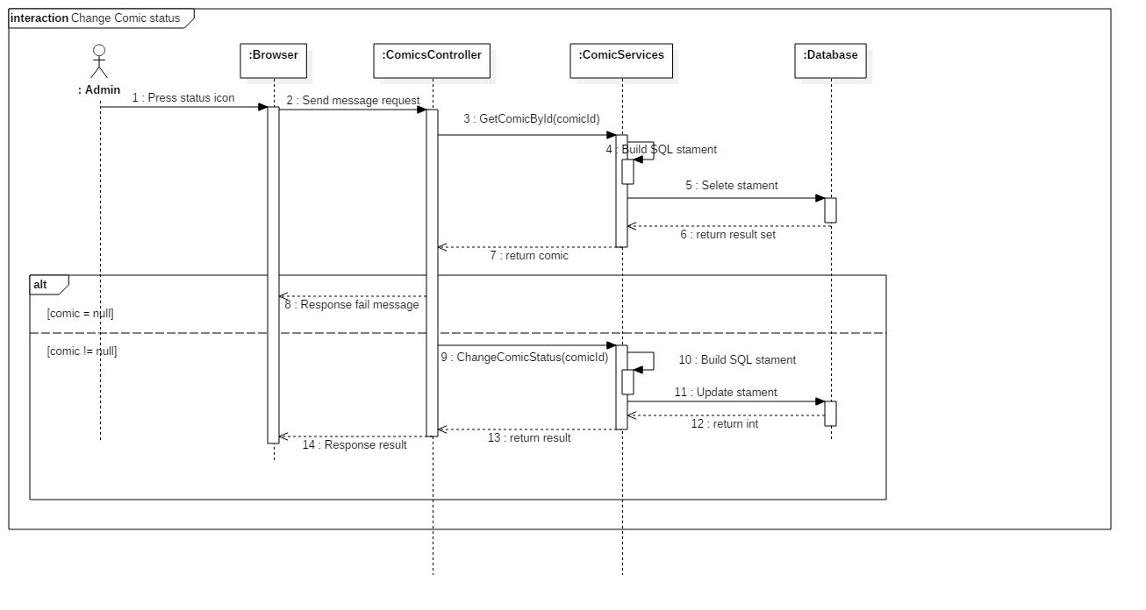

Figure 30: Change comic status

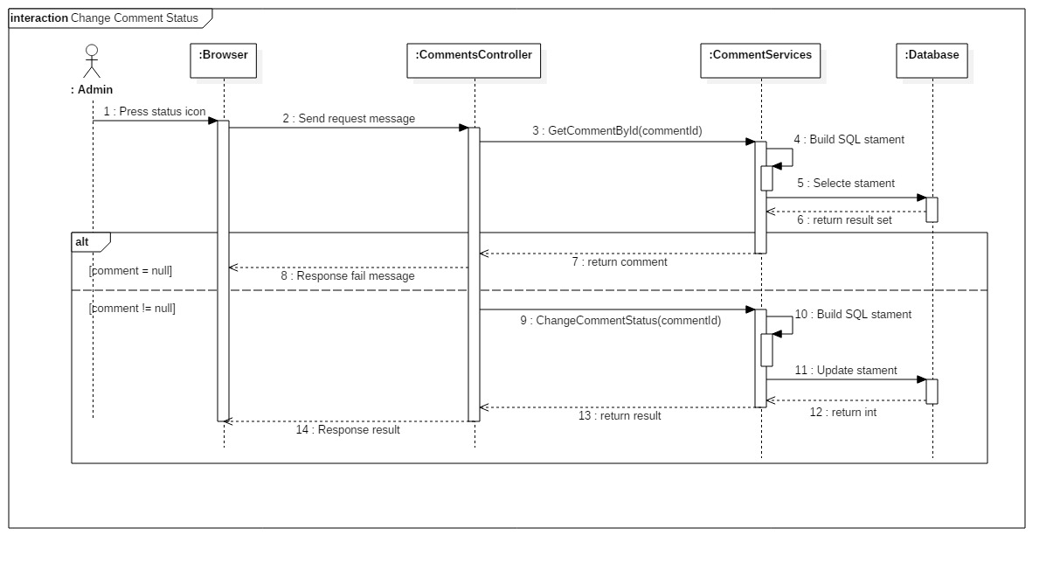

Figure 31: Change comment status

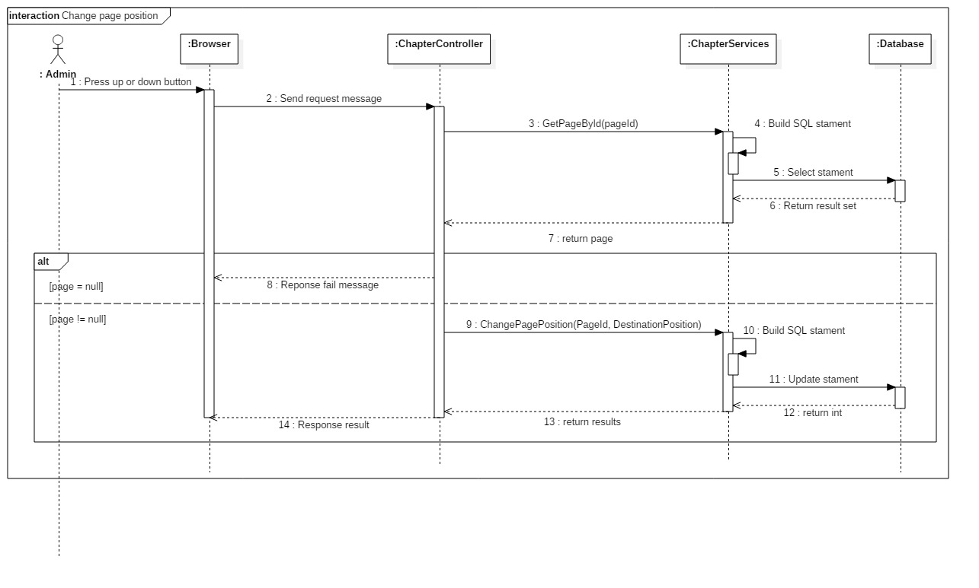

Figure 32: Change page position

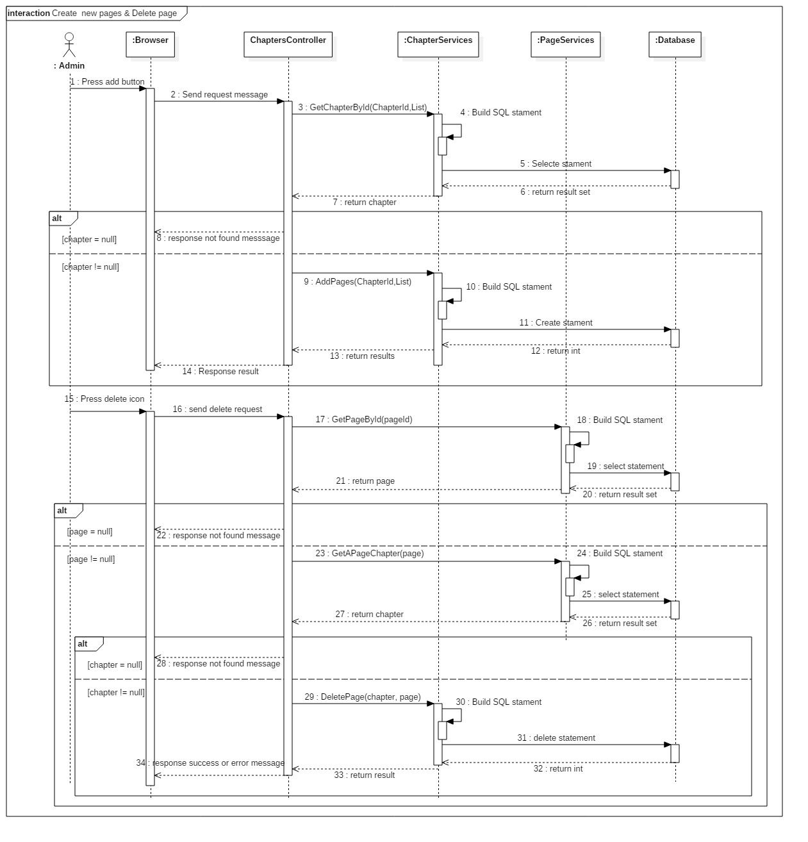

Figure 33: Create a new page & Delete page

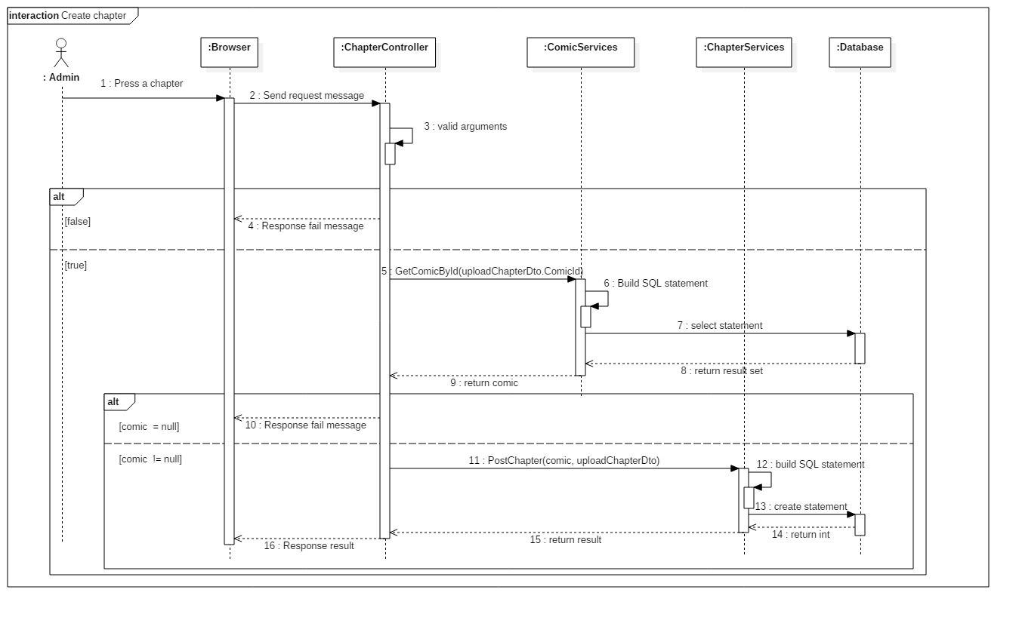

Figure 34: Create chapter

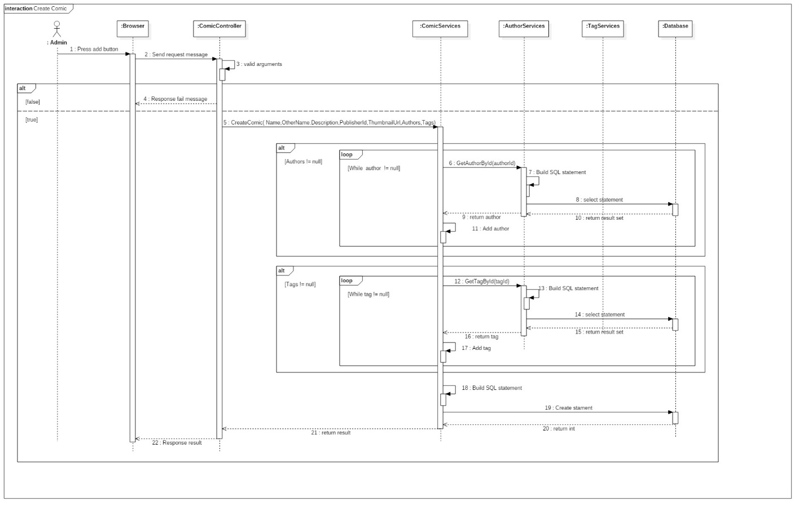

Figure 34: Create comic

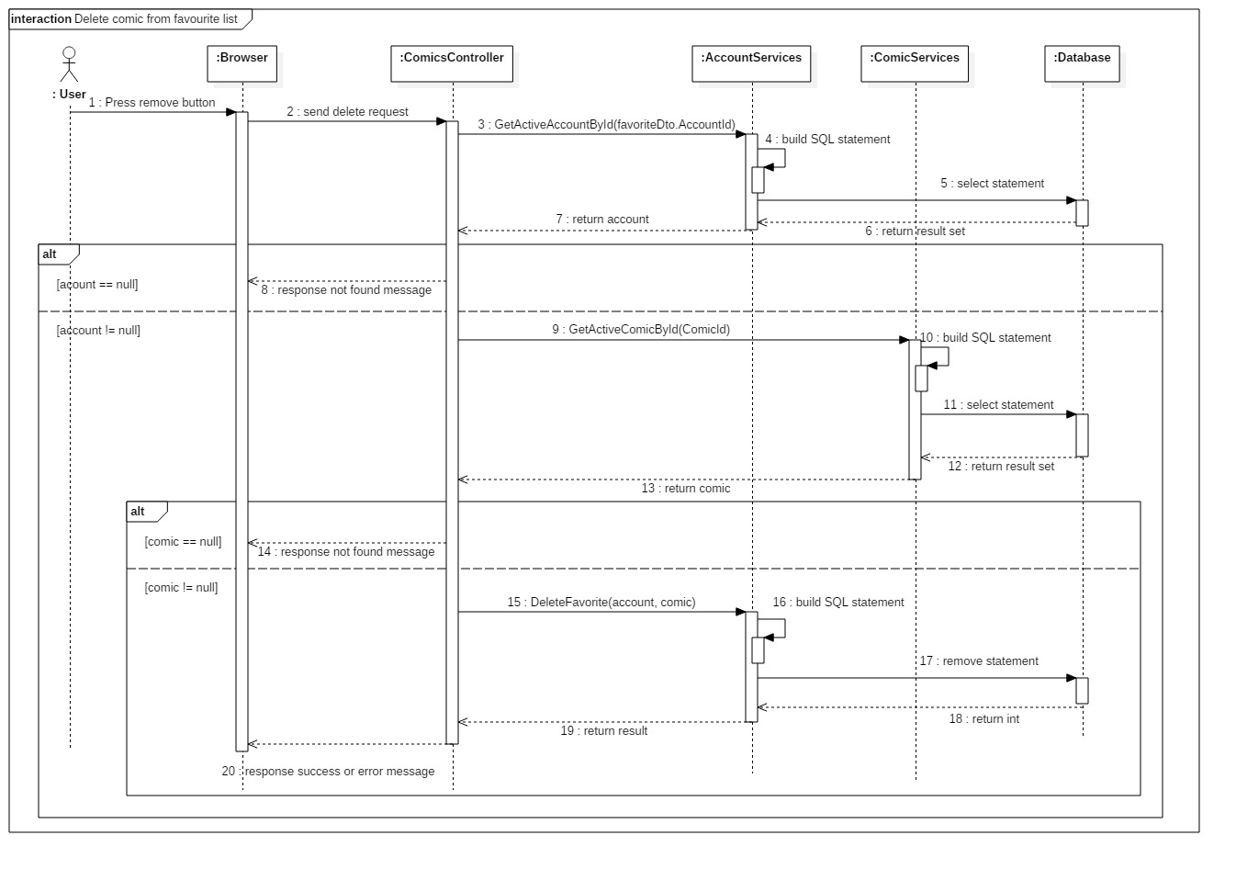

Figure 34: Delete comic from favourite list

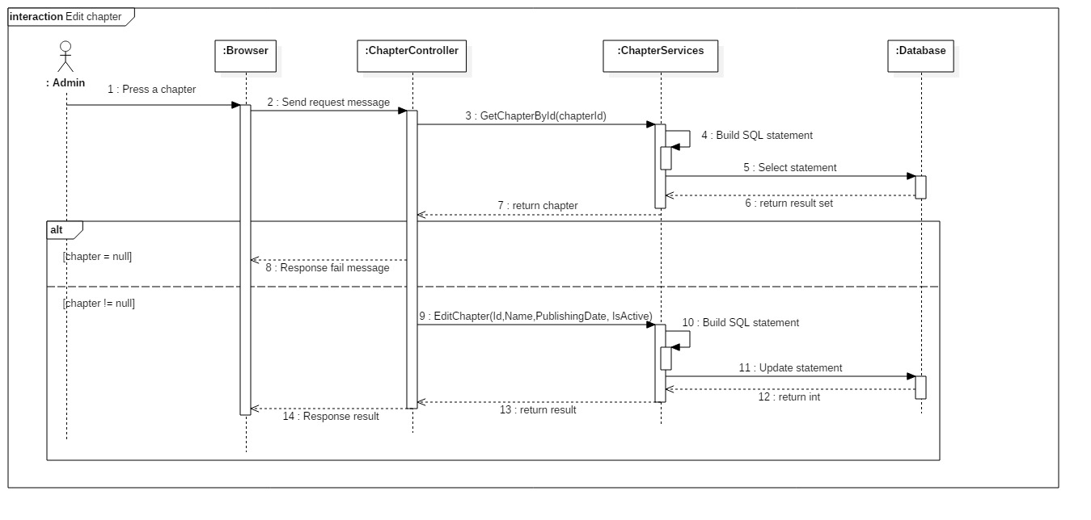

Figure 34: Edit chapter

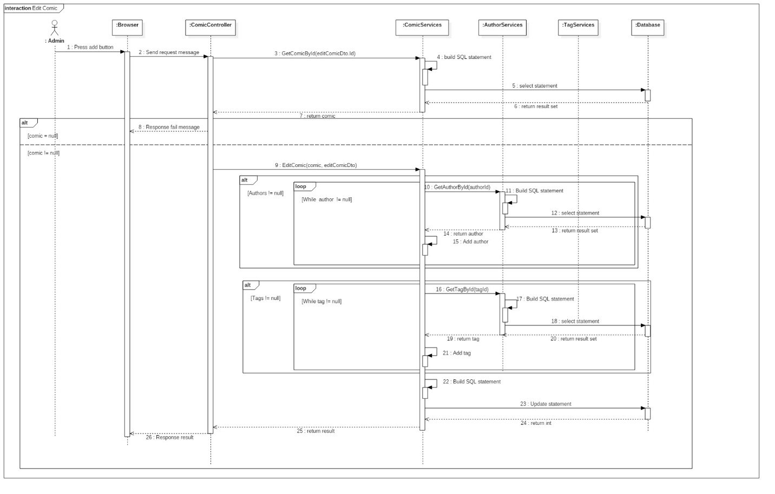

Figure 34: Edit comic

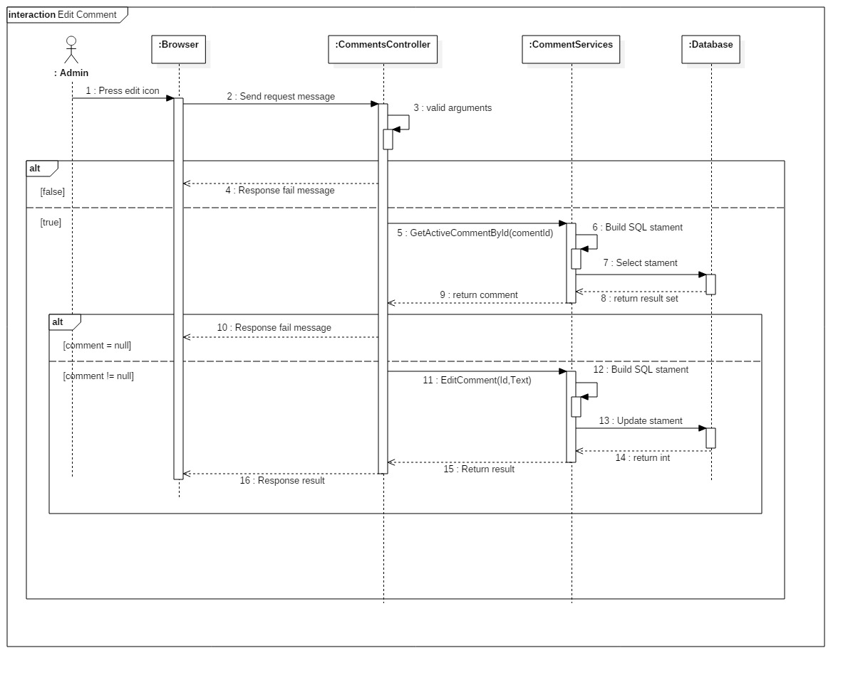

Figure 34: Edit comment

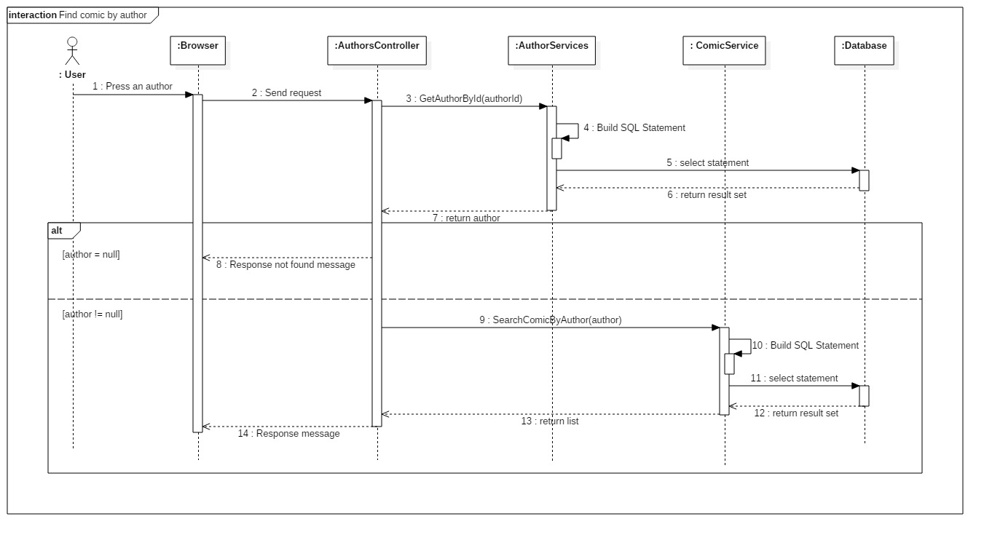

Figure 34: Find comic by author

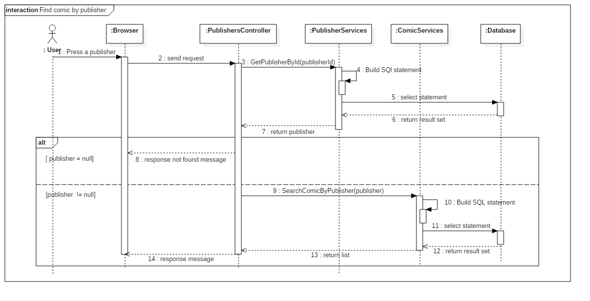

Figure 34: Find comic by publisher

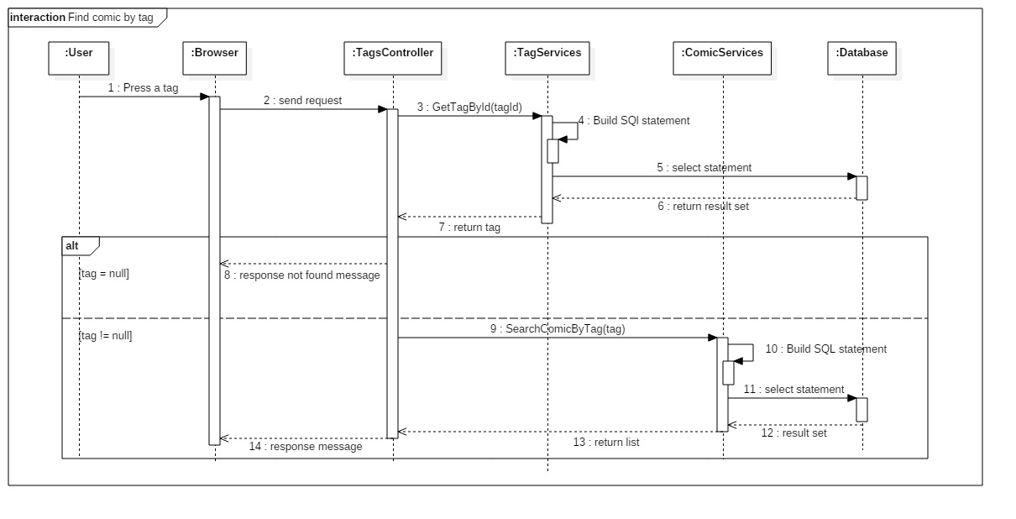

Figure 34: Find comic by tag

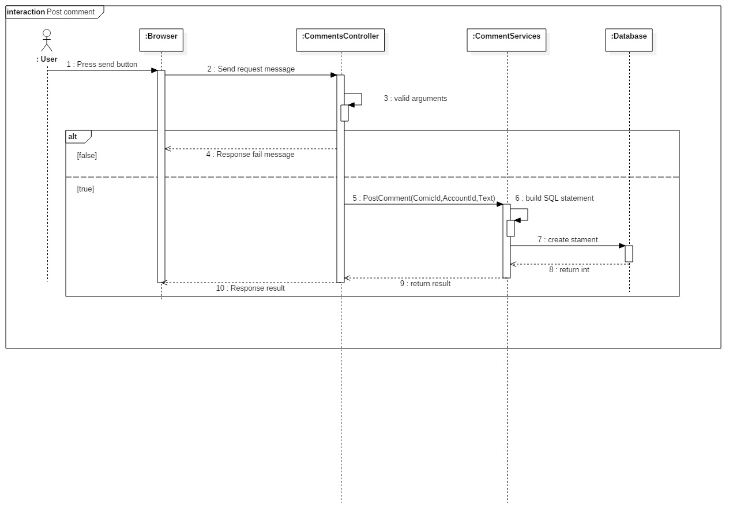

Figure 34: Post comment

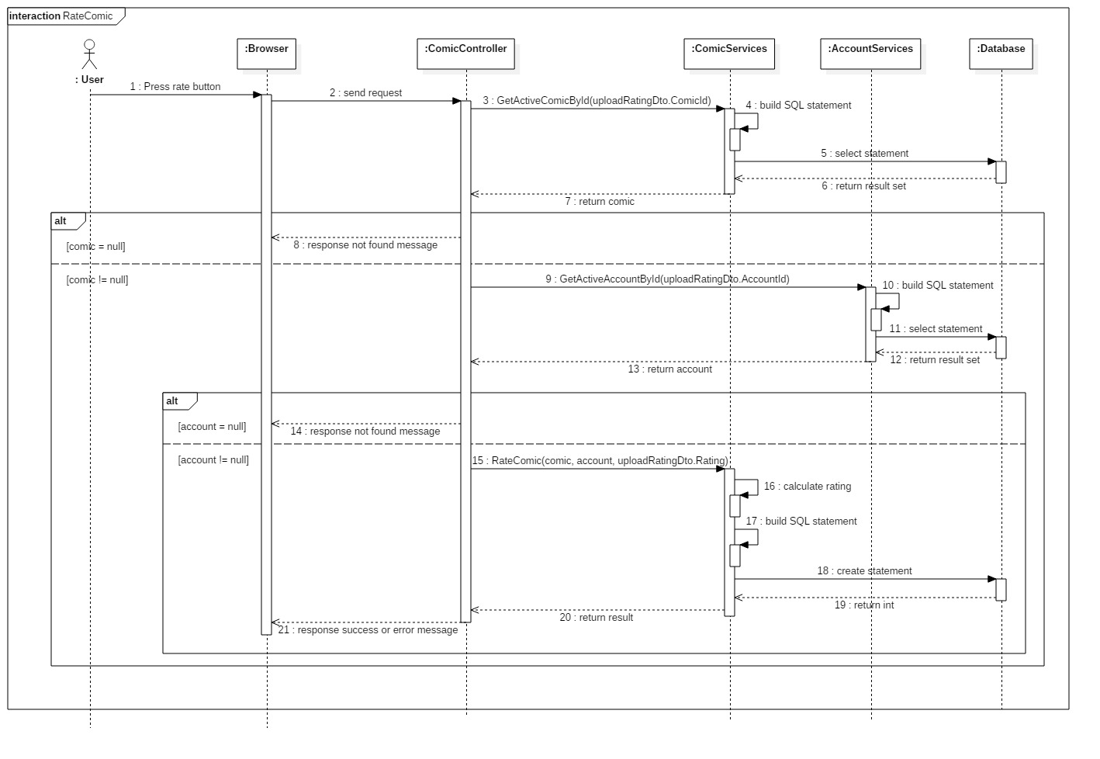

Figure 34: Rate comic

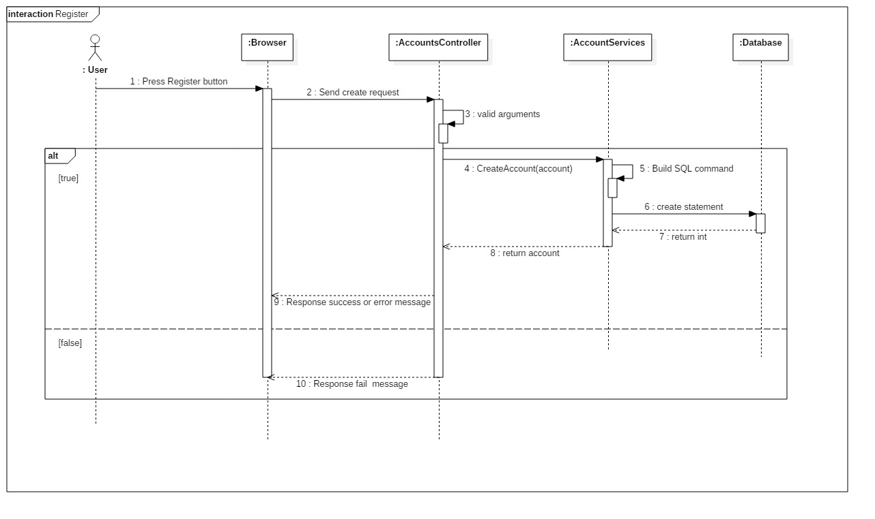

Figure 34: Register

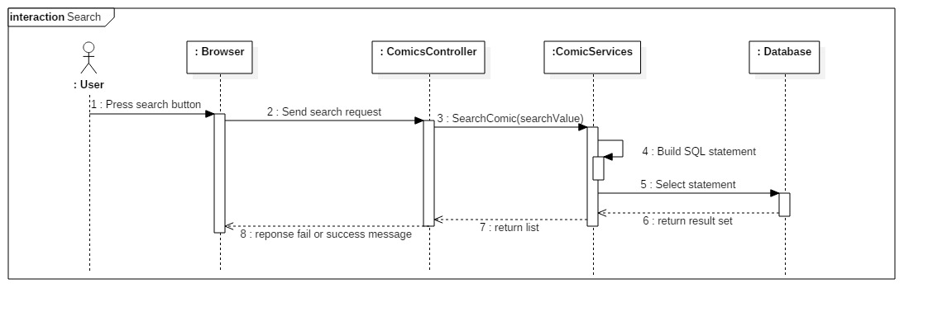

Figure 34: Search

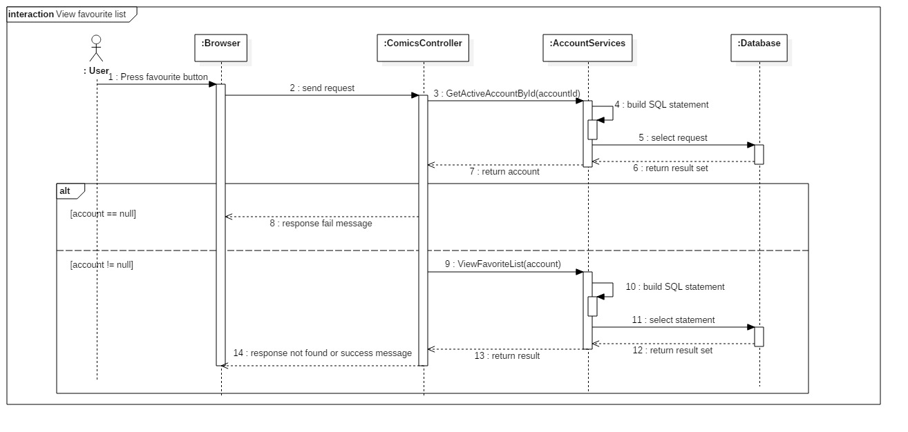

Figure 34: View favourite list

# Data View

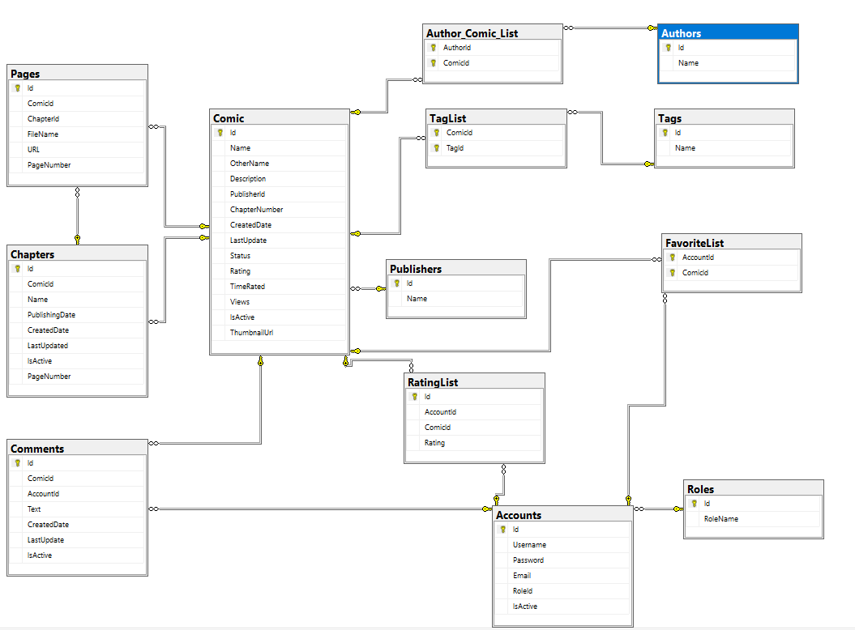

Figure : Database structure